**Assignment - 18 A Job Ready Bootcamp in C++, DSA and IOT**

String and Functions in C Language

**1. Write a function to calculate length of the string**

#include<stdio.h>

#include<string.h>

int length(char str[]);

int main()

{

char str[15];

int size;

printf("Enter a string\n");

gets(str);

size=length(str);

printf("Size of string is %d",size);

}

int length(char str[])

{

int c=0,i;

for(i=0;str[i];i++)

c++;

return c;

}

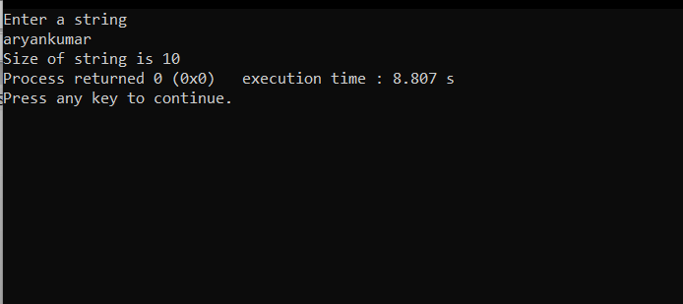

**2. Write a function to reverse a string.**

#include<stdio.h>

#include<string.h>

int length(char str[]);

void reverse(char s[],int size);

int main()

{

char str[15];

int size;

printf("Enter a string\n");

gets(str);

size=length(str);

reverse(str,size);

return 0;

}

int length(char str[])

{

int c=0,i;

for(i=0;str[i];i++)

c++;

return c;

}

void reverse(char s[],int size)

{

int i,j;

char temp=0;

j=size-1;

for(i=0;i<=j;i++)

{

temp=s[i];

s[i]=s[j];

s[j]=temp;

j--;

}

printf("Reverse of string is ==> %s",s);

}

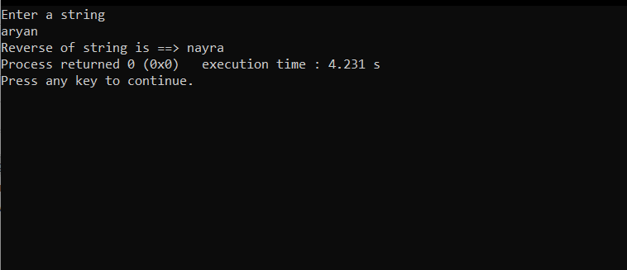

**3. Write a function to compare two strings.**

#include<stdio.h>

#include<string.h>

int compare(char fs[],char ss[]);

int main()

{

char fs[15],ss[15];

printf("Enter two string\n");

gets(fs);

gets(ss);

if(compare(fs,ss))

printf("strings are Same");

else

printf("Strings are not same");

return 0;

}

int compare(char fs[],char ss[])

{

int i,count=0;

for(i=0;fs[i]&&ss[i];i++)

{

if(fs[i]==ss[i])

continue;

else

return 0;

}

return 1;

}

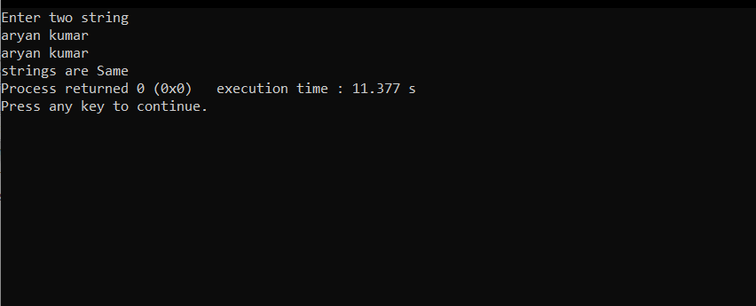

**4. Write a function to transform string into uppercase**

#include<stdio.h>

#include<string.h>

void upper(char s[]);

int main()

{

char s[15];

printf("Enter a string\n");

gets(s);

upper(s);

return 0;

}

void upper(char s[])

{

int i;

for(i=0;s[i];i++)

{

s[i]=s[i]-32;

}

printf("%s",s);

}

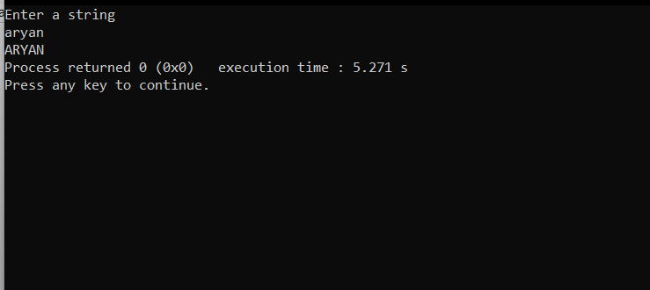

**5. Write a function to transform a string into lowercase**

#include<stdio.h>

#include<string.h>

void lower(char s[]);

int main()

{

char s[15];

printf("Enter a string\n");

gets(s);

lower(s);

return 0;

}

void lower(char s[])

{

int i;

for(i=0;s[i];i++)

{

s[i]=s[i]+32;

}

printf("%s",s);

}

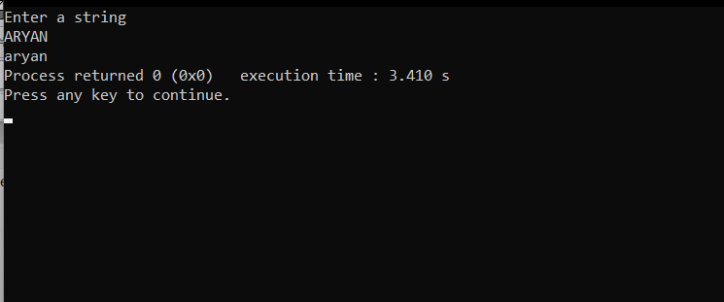

**6. Write a function to check whether a given string is an alphanumeric string or not. (Alphanumeric string must contain at least one alphabet and one digit)**

#include<stdio.h>

#include<string.h>

void alphanumcheck(char s[]);

int main()

{

char s[15];

printf("Enter a string\n");

gets(s);

alphanumcheck(s);

return 0;

}

void alphanumcheck(char s[])

{

int i,c=0,k=0;

for(i=0;s[i];i++)

{

if(s[i]>=65 || s[i]<=122)

c++;

else if (s[i]>=48 || s[i]<= 57)

k++;

}

if(c>=1 && k>=1)

printf("Number is alphanumeric");

else

printf("Number is Not alphanumeric");

}

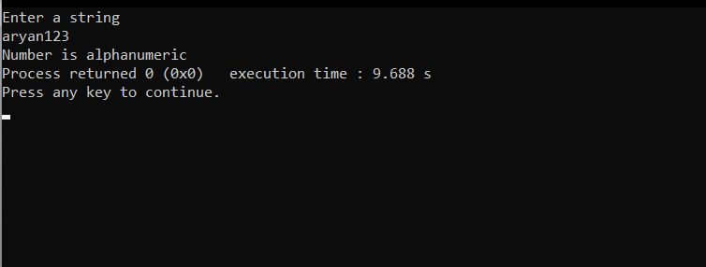

**7. Write a function to check whether a given string is palindrome or not.**

#include<stdio.h>

#include<string.h>

int length(char str[]);

void palindrome(char s[],int size);

int main()

{

char str[15];

int size;

printf("Enter a string\n");

gets(str);

size=length(str);

palindrome(str,size);

return 0;

}

int length(char str[])

{

int c=0,i;

for(i=0;str[i];i++)

c++;

return c;

}

void palindrome(char s[],int size)

{

int i,j;

char temp=0,k=0;

j=size-1;

for(i=0;i<=j;i++)

{

if(s[i]==s[j])

j--;

else

k++;

}

if(k>=1)

printf("String is not palindrome");

else

printf("String is palindrome");

}

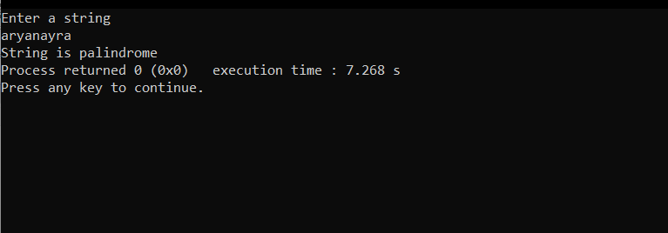

**8. Write a function to count words in a given string**

#include<stdio.h>

#include<string.h>

int countword(char str[]);

int main()

{

char str[100];

printf("Enter a string\n");

gets(str);

printf("Total words in string are %d",countword(str));

return 0;

}

int countword(char str[])

{

int c=0,i;

for(i=0;str[i];i++)

{

if(str[i]>=65 && str[i]<=122)

c++;

}

return c;

}

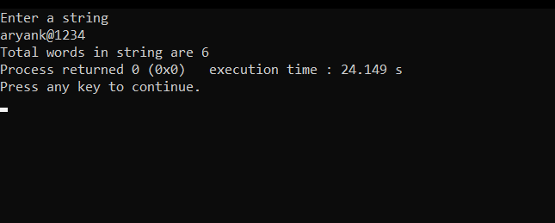

**9. Write a function to reverse a string word wise. (For example if the given string is “Mysirg Education Services” then the resulting string should be “Services Education Mysirg” )**

#include<stdio.h>

#include<string.h>

void swap(char s[],int i,int j)

{

char temp;

while(i<=j)

{

temp=s[i];

s[i]=s[j];

s[j]=temp;

i++;

j--;

}

}

int main()

{

char s[100];

int i,start=0,end=0,flag=0;

printf("Enter string\n");

gets(s);

while(s[i]!='\0')

{

while(s[i]!=' ')

{

if(s[i]=='\0')

{

flag=1;

break;

}

end++;

i++;

}

swap(s,start,end-1);

if(flag==1)

break;

start=end++;

i++;

}

swap(s,0,i-1);

printf("%s",s);

return 0;

}

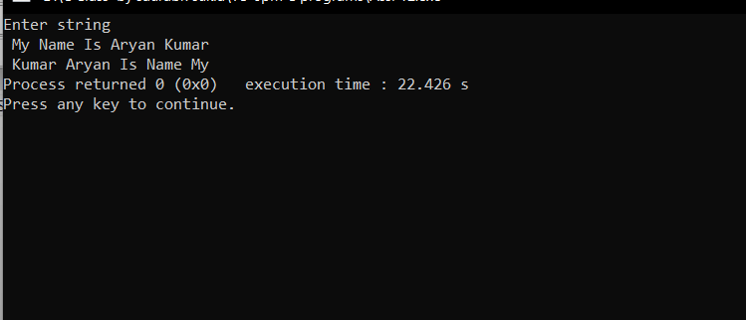

**10. Write a function to find the repeated character in a given string.**

#include <stdio.h>

#include <string.h>

void strSort(char str[])

{

for (int i = 0; str[i]; i++)

{

for (int j = i+1; str[j]; j++)

{

if (str[i] < str[j])

{

int temp = str[i];

str[i] = str[j];

str[j] = temp;

}

}

}

}

void reapetedChar(char str[])

{

strSort(str);

int i = 0, j, flag;

while (i<strlen(str))

{

flag = 1;

for (j = i + 1; str[j]; j++)

{

if (str[i] == str[j])

flag = 0;

else

break;

}

if (flag == 0)

printf("%c ", str[i]);

i = j;

}

}

int main()

{

char str[100];

printf("Enter string: ");

fgets(str, 100, stdin);

printf("Reapted character in given string :\n");

reapetedChar(str);

return 0;

}

